LAB : OHM’S LAW
Objective
The objective of this lab experiment is to learn to build a simple circuit with one resistor and one DC source.
Theory
Ohm’s Law states that the electric current 𝐼 passing through a resistor with resistance 𝑅 is proportional to the voltage (electric potential difference) 𝑉 across the resistor and inversely proportional to the resistance.
$$I=\frac{V}{R}$$
PROCEDURE
- A simple circuit was built using the PhET Simulation tool.
- The DC power source was set to 12.0 V.
- Three resistors 𝑅1=10.0 Ω, 𝑅2=20.0 Ω, and 𝑅3=30.0 Ω were created and each resistor put into the circuit one at a time, voltage measured using the voltmeter and the values recorded on Table 1.
- With the power source still set at 12.0 V, the current of each resistor was measured and the values recorded on Table 1. 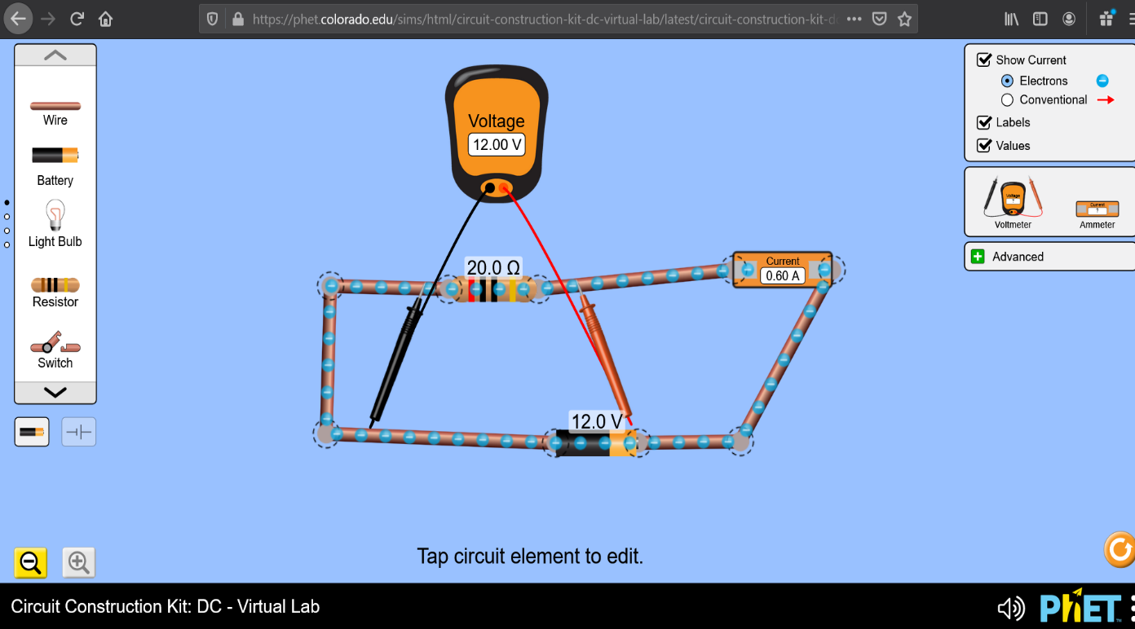
Figure 1: Experimental setup 1
- The 10.0 Ω resistor was put in the circuit and the voltage of the power supply increased from 1 𝑉 to 5 𝑉 using 1 𝑉 increments.
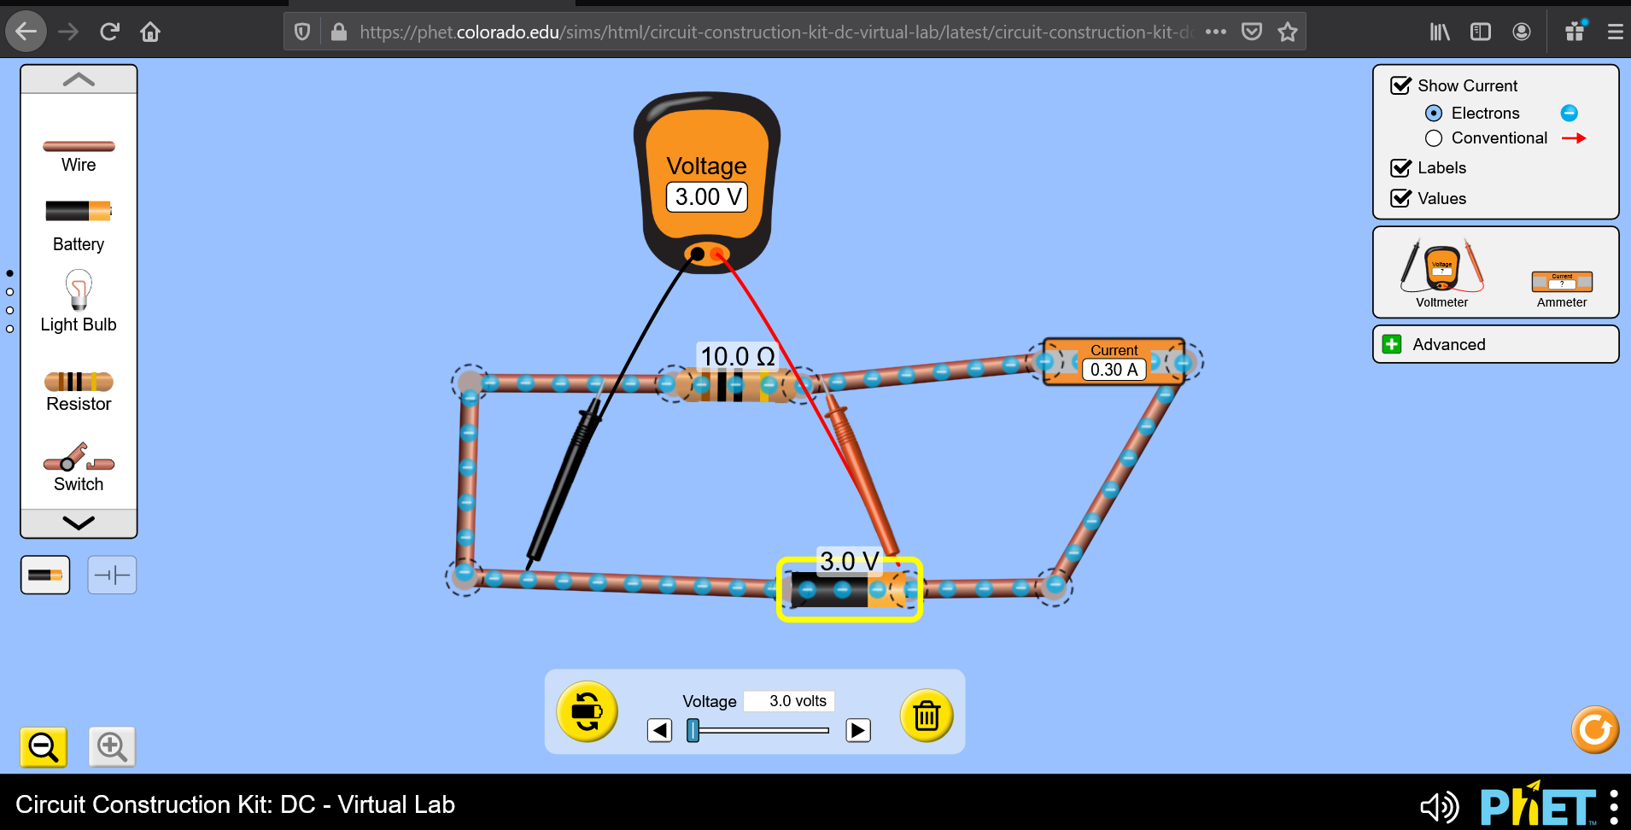
Figure 2: Experimental setup 2
DATA TABLE 1
DC Power Source: 12.0 V
Resistance | Measured voltage | Calculated current | Measured current | % difference in the current
10.0 Ω | 12.0 V | 1.2 A | 1.2 A | 0.0
20.0 Ω | 12.0 V | 0.6 A | 0.6 A | 0.0
30.0 Ω | 12.0 V | 0.4A | 0.2 A | 0.0

DATA TABLE 2
Resistance: 10.0 Ω
Voltage(volt) | Measured current(ampere) | Slope | %error in resistance
1.0 | 0.1 | 10.0 | 0.0
2.0 | 0.2 | 10.0 | 0.0
3.0 | 0.3 | 10.0 | 0.0
4.0 | 0.4 | 10.0 | 0.0
5.0 | 0.5 | 10.0 | 0.0

From the graph $slope= \frac{3.0-2.0}{0.3-0.2}=10.0$
This is equal to the resistance offered by the 10.0 Ω resistor.
Conclusion
In the above setups, Ohm’s law was obeyed; the current passing through a resistor was found to be directly proportional to the voltage across the resistor and inversely proportional to the resistance offered by the resistor.

